**Hw_3**

Shyam Sunder Rajasekaran

5088838103

1. **COLMAP**

10 images with exhaustive

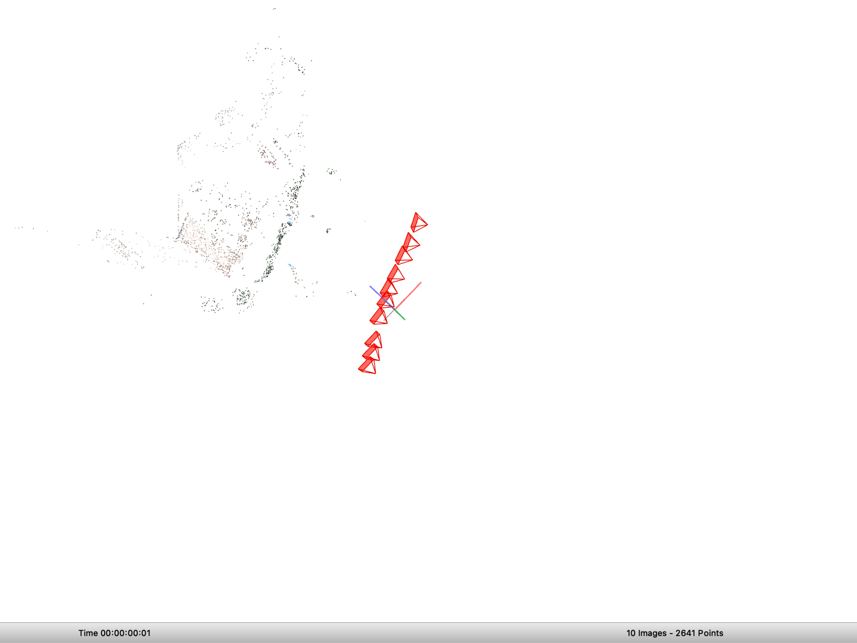

Model Stats:

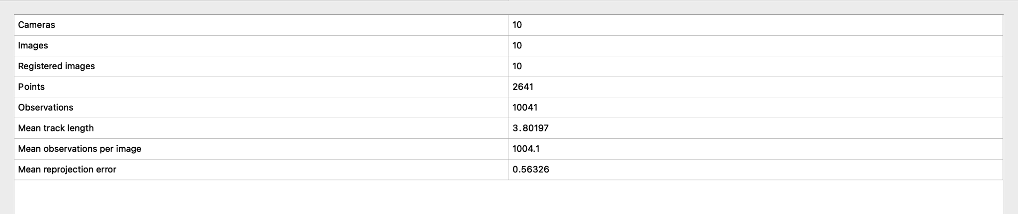

Key Feature points of images 2 and 7:

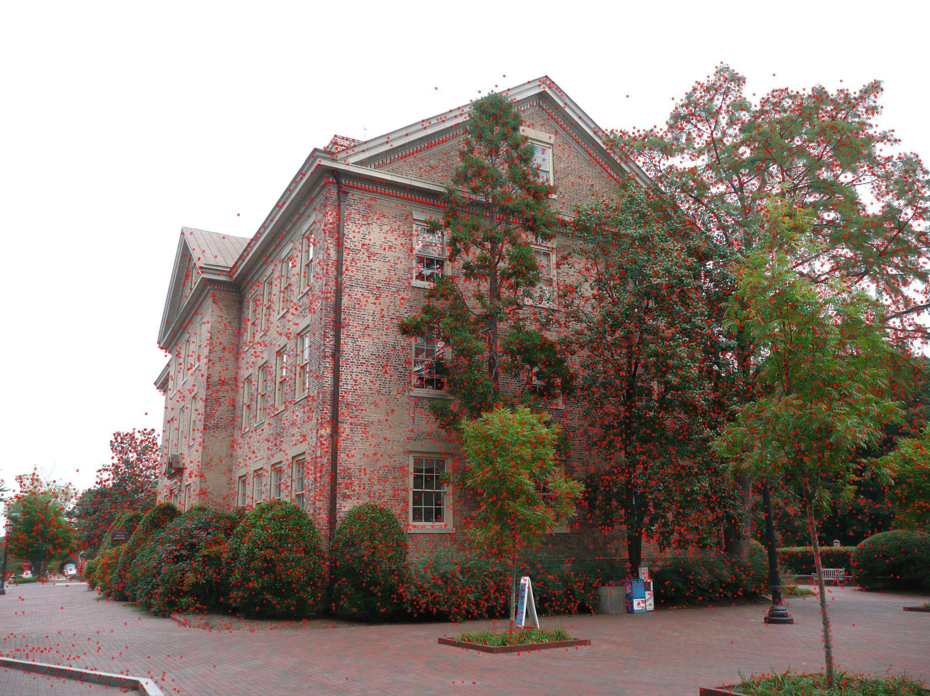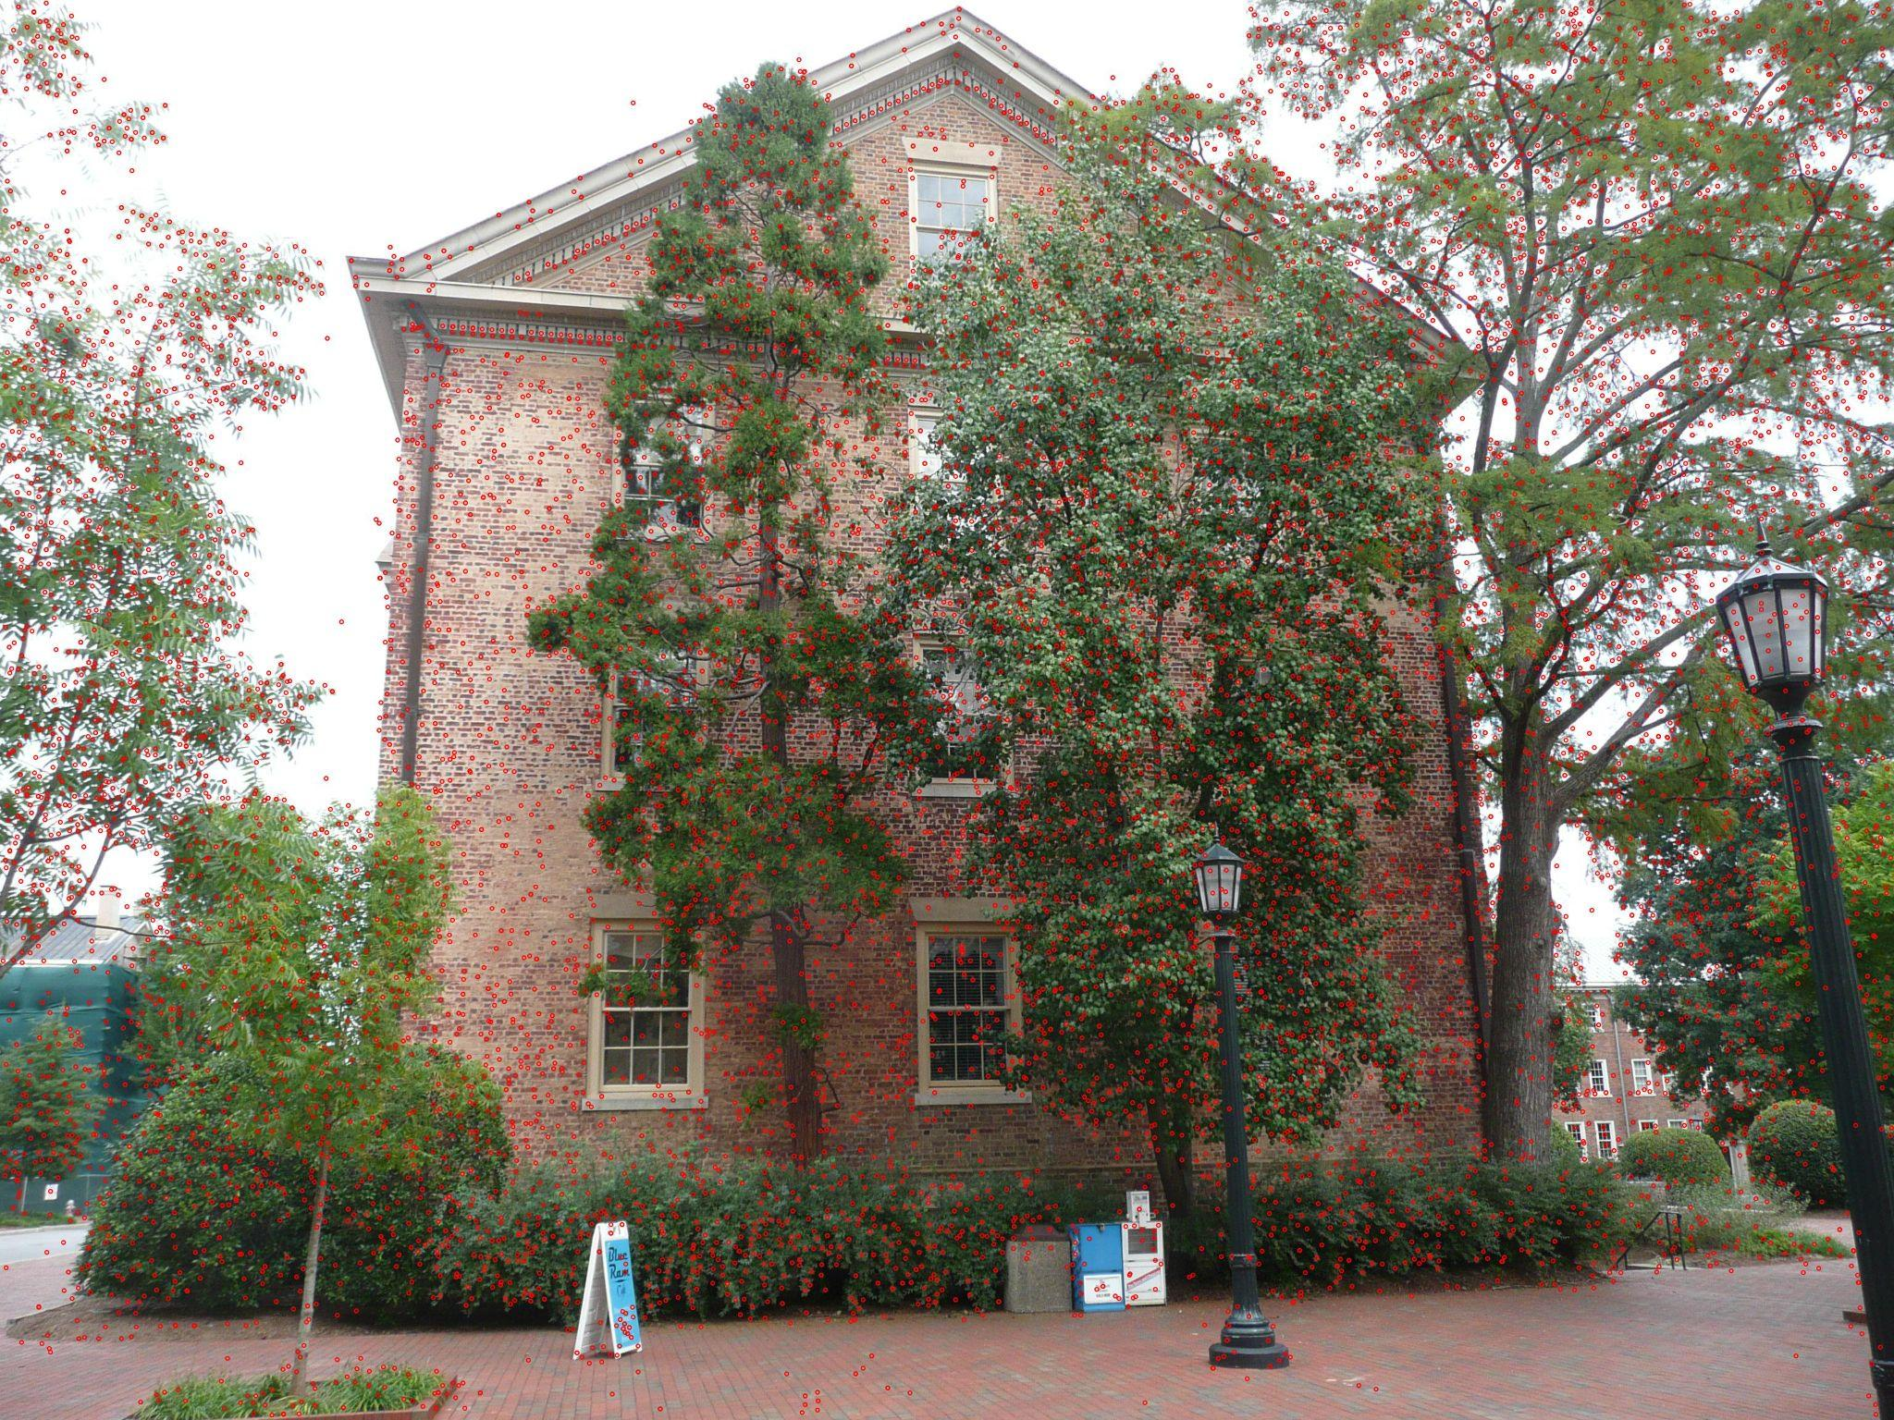

Match points of two pair of images from first 10 samples:

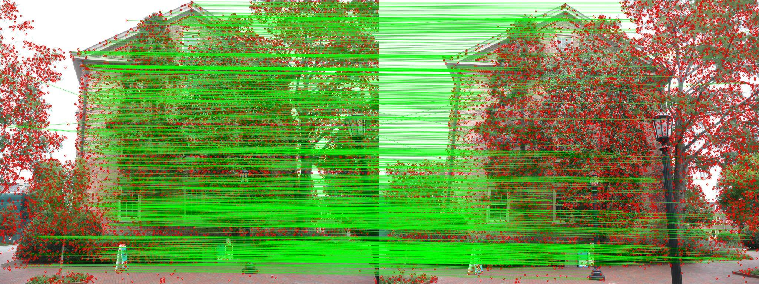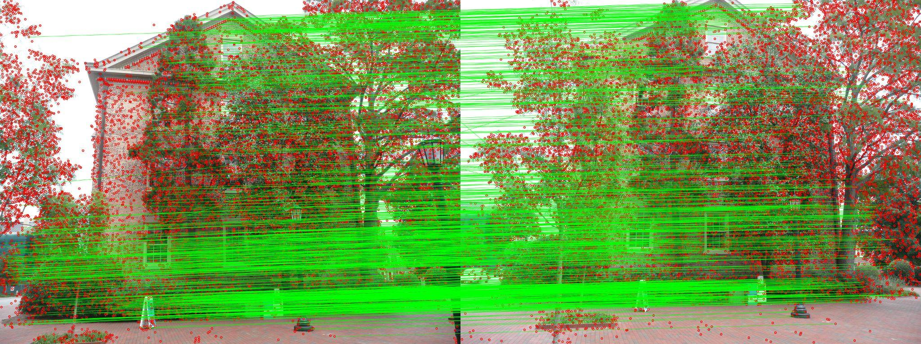

Sequential :10 images

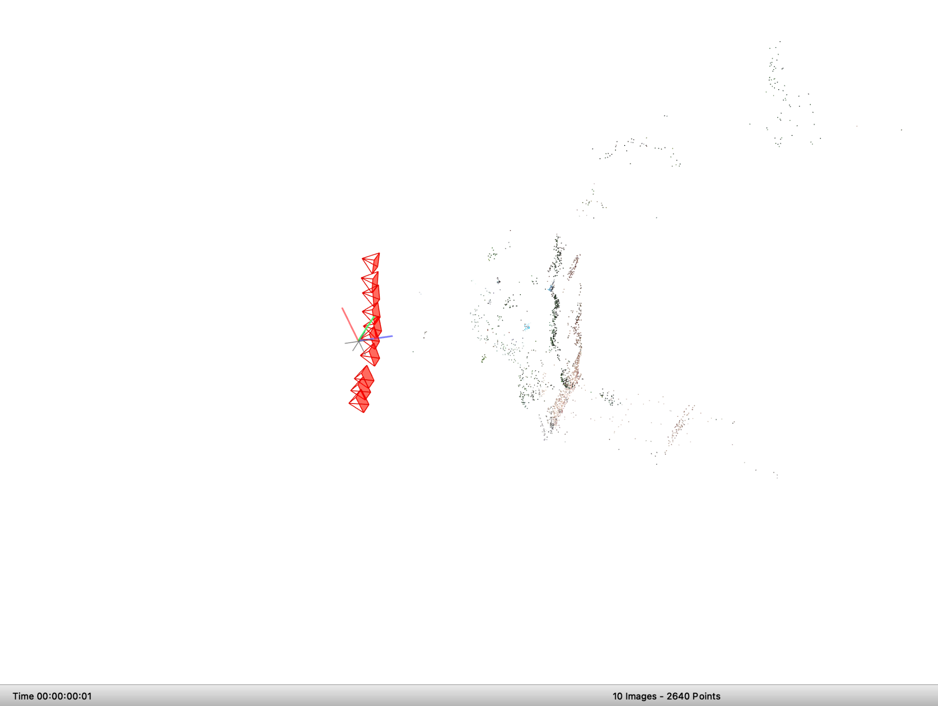

Model Stats:

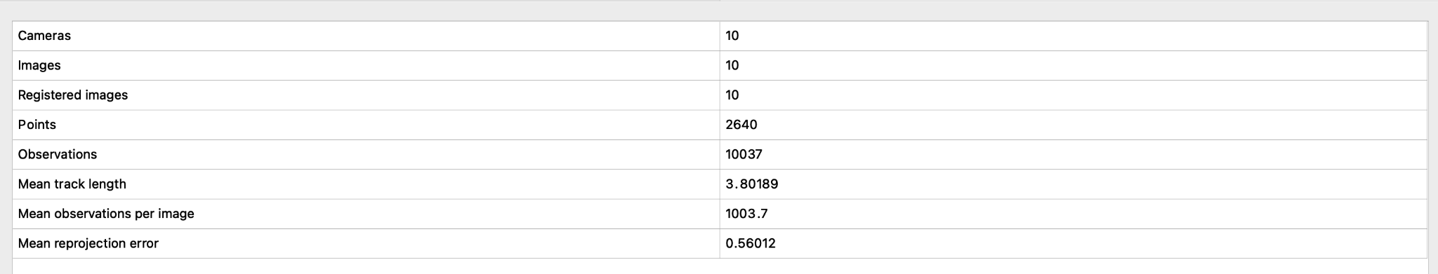

Key Feature points images 3 and 9:

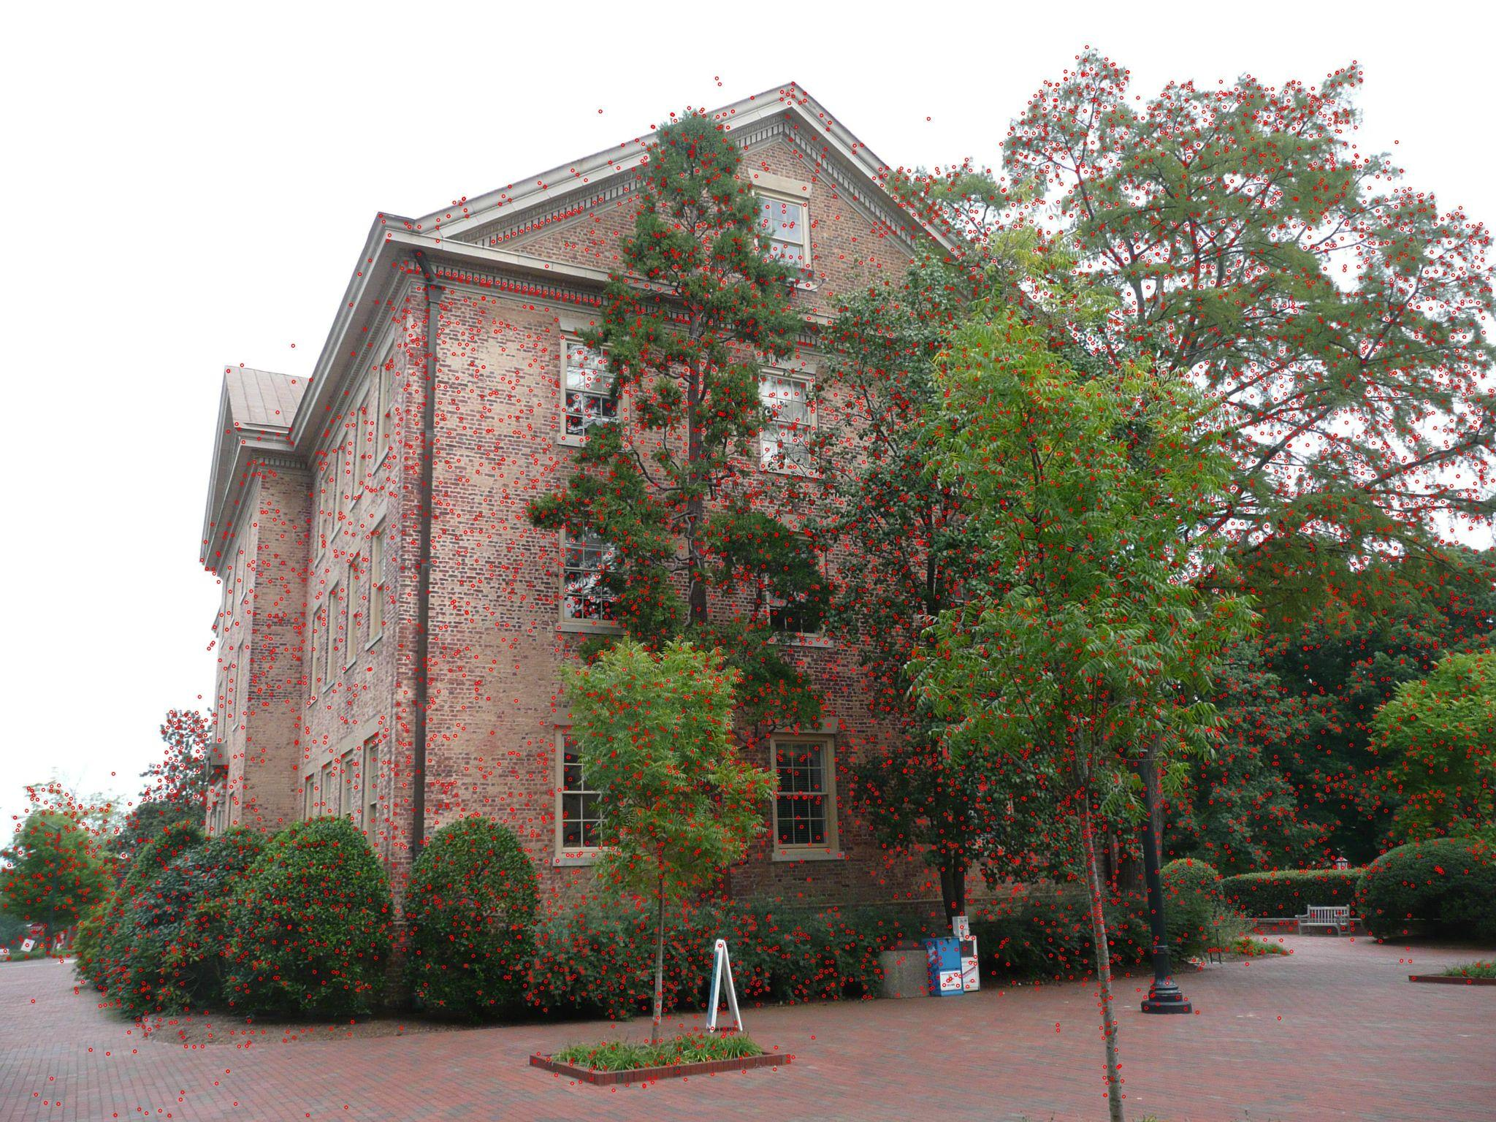\

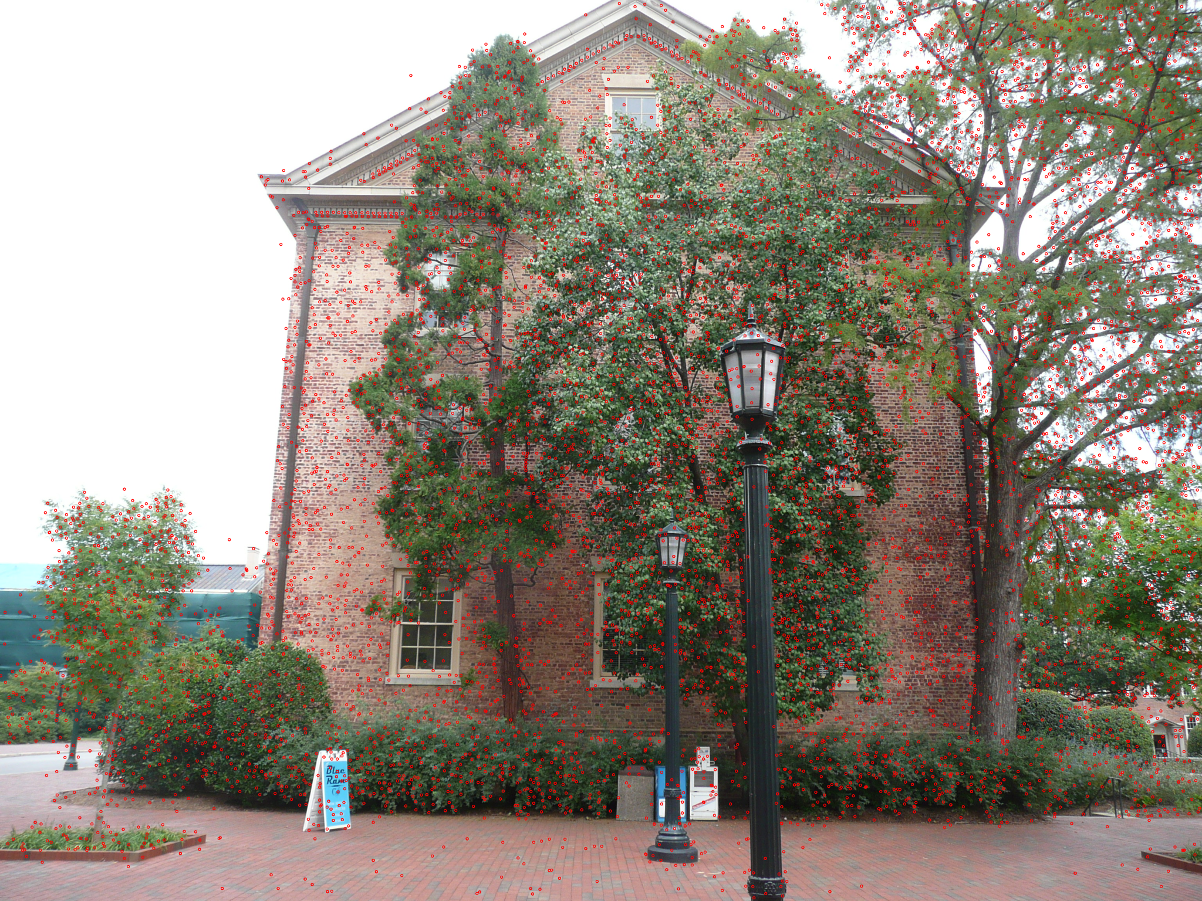

Overlap matches between pairs 8 and 7:

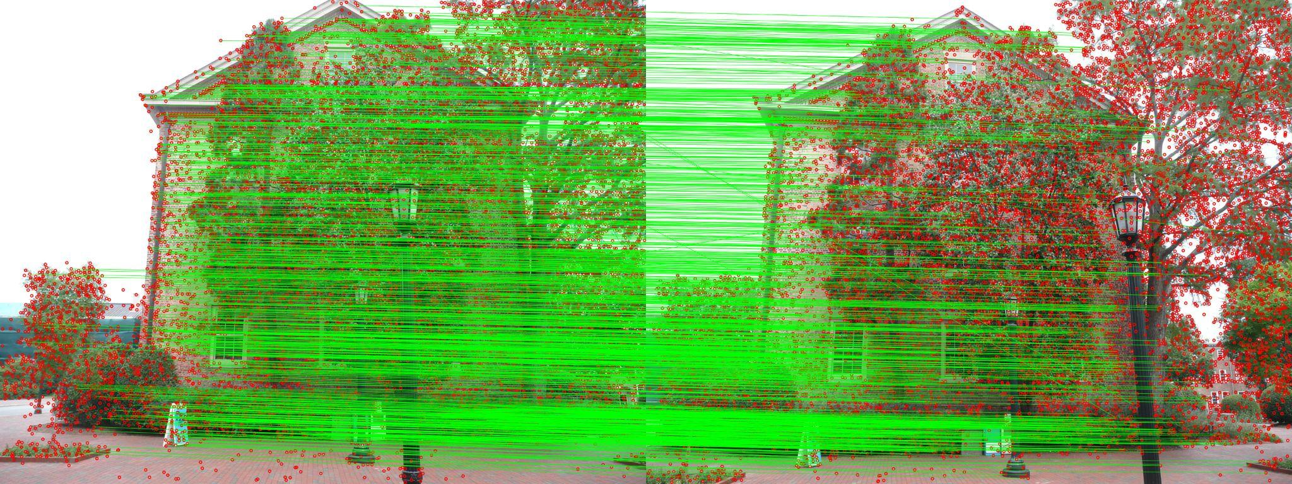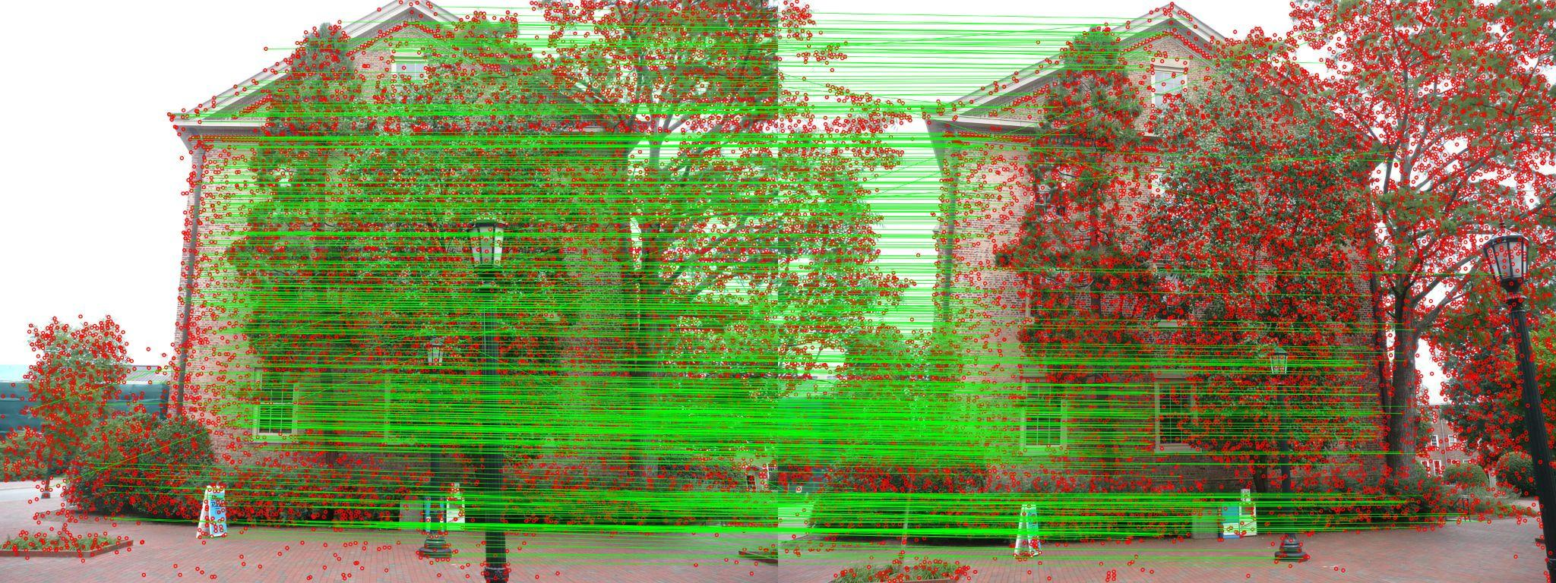

20 images Exhaustive:

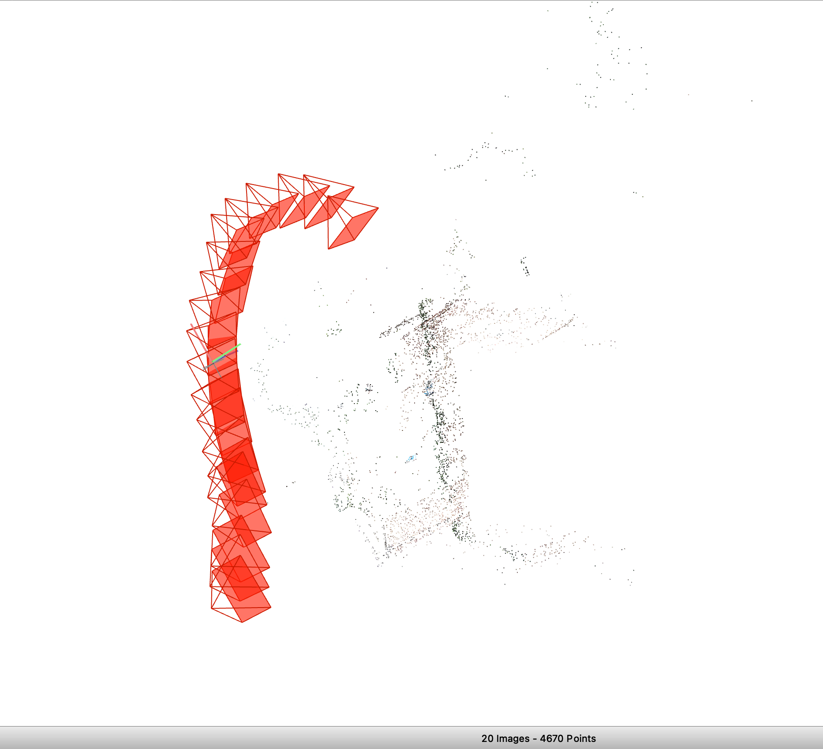

Model Stats:

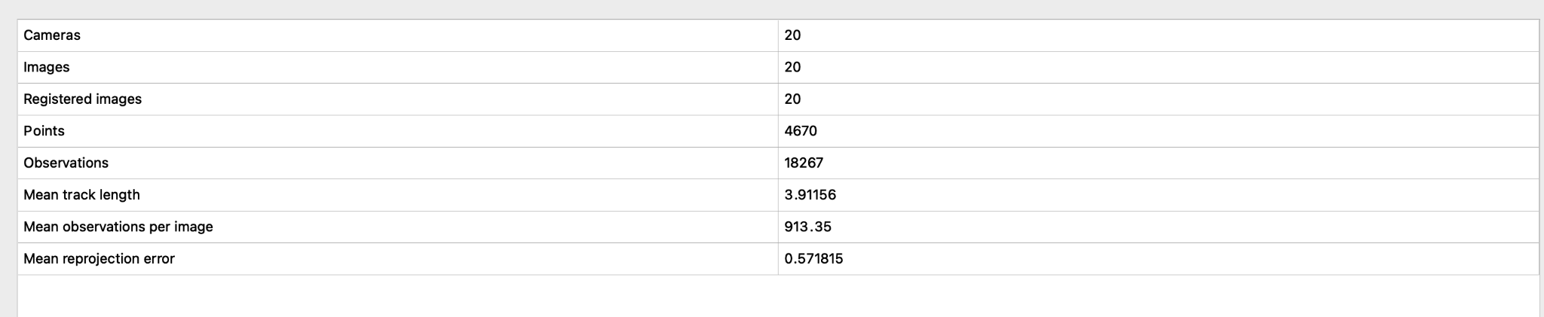

Match matrix:



Key feature points 10 and 15:

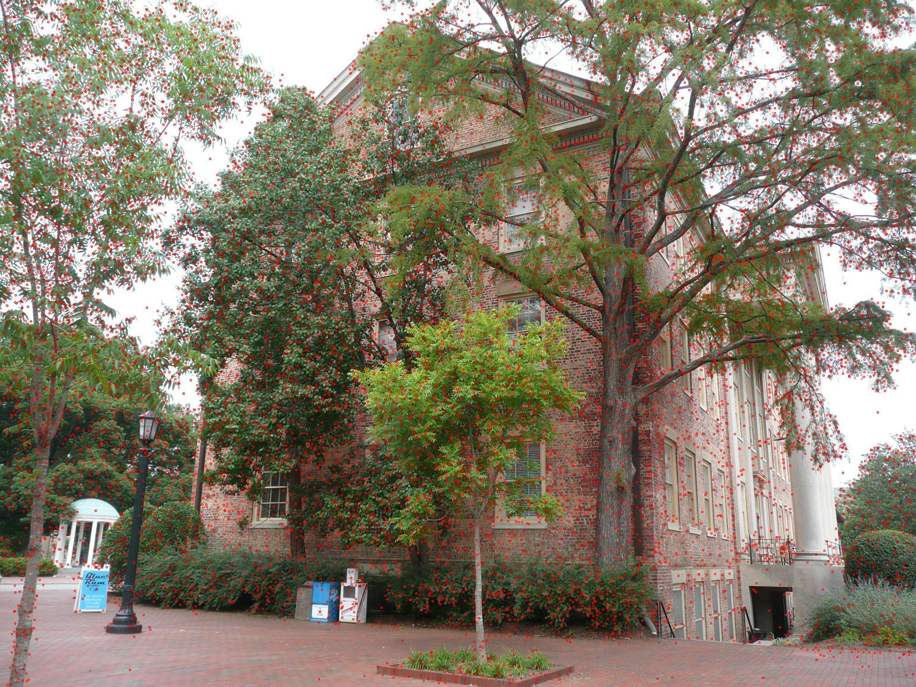

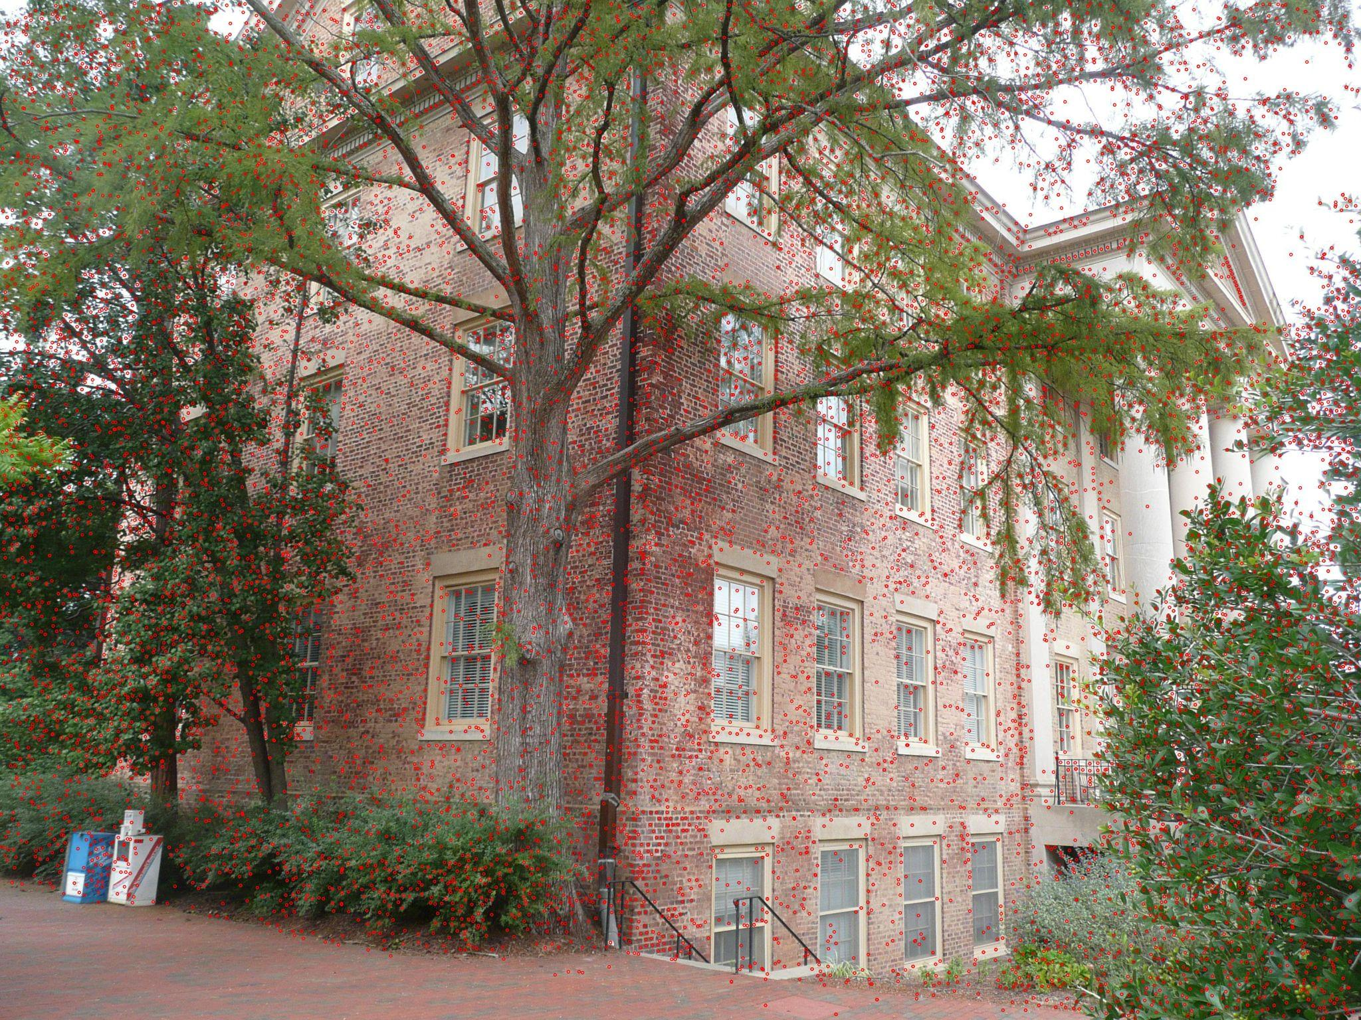

Overlap match between img 16-17 and 13-12:

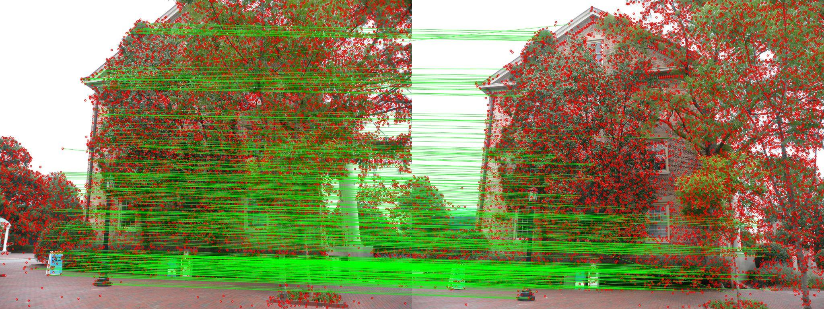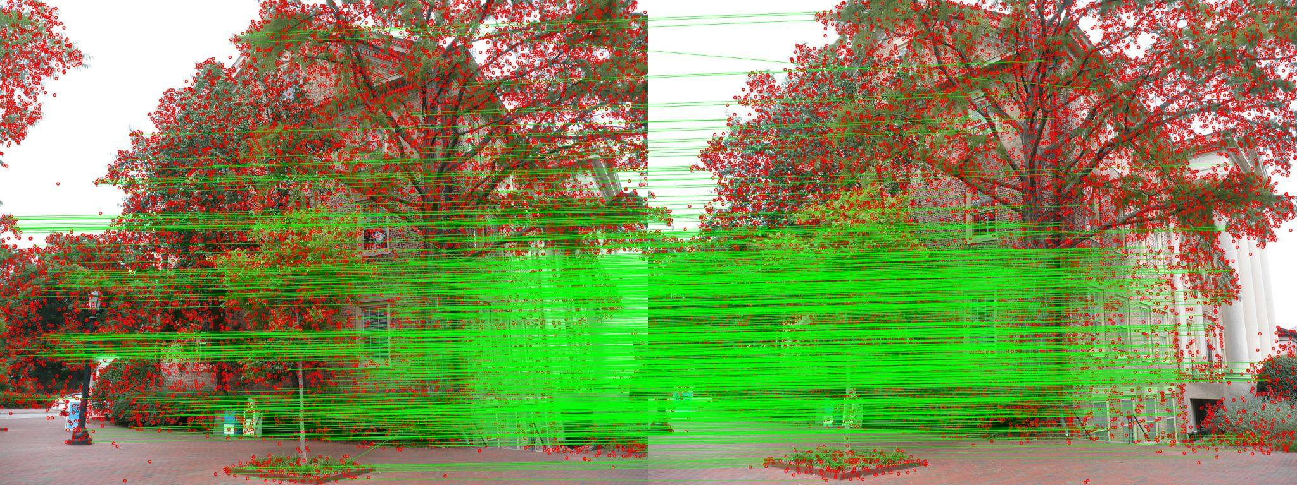

20 images Sequential:  
  
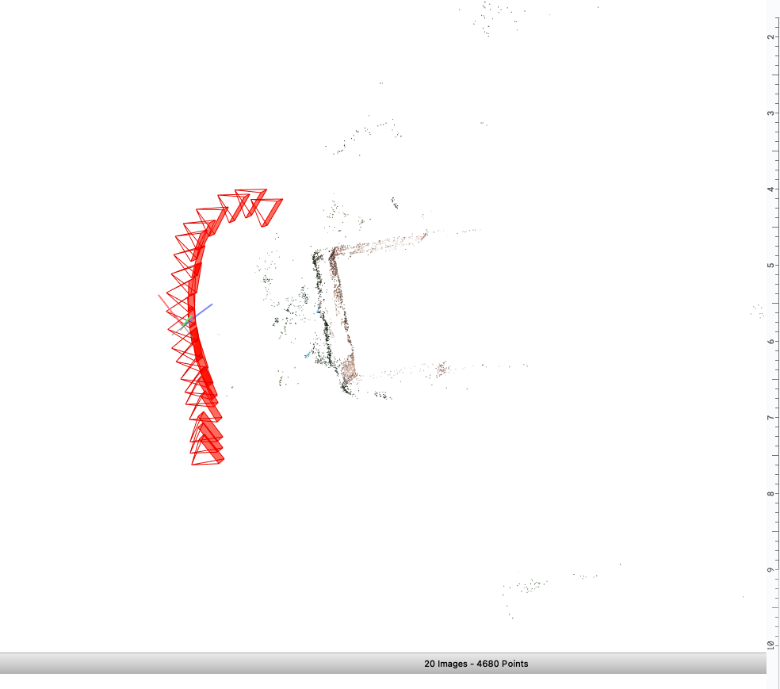

Model stats:  
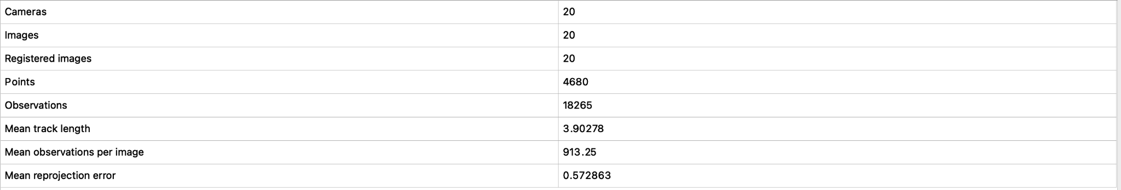

Match matrix:



Key feature points of 11 and 18:

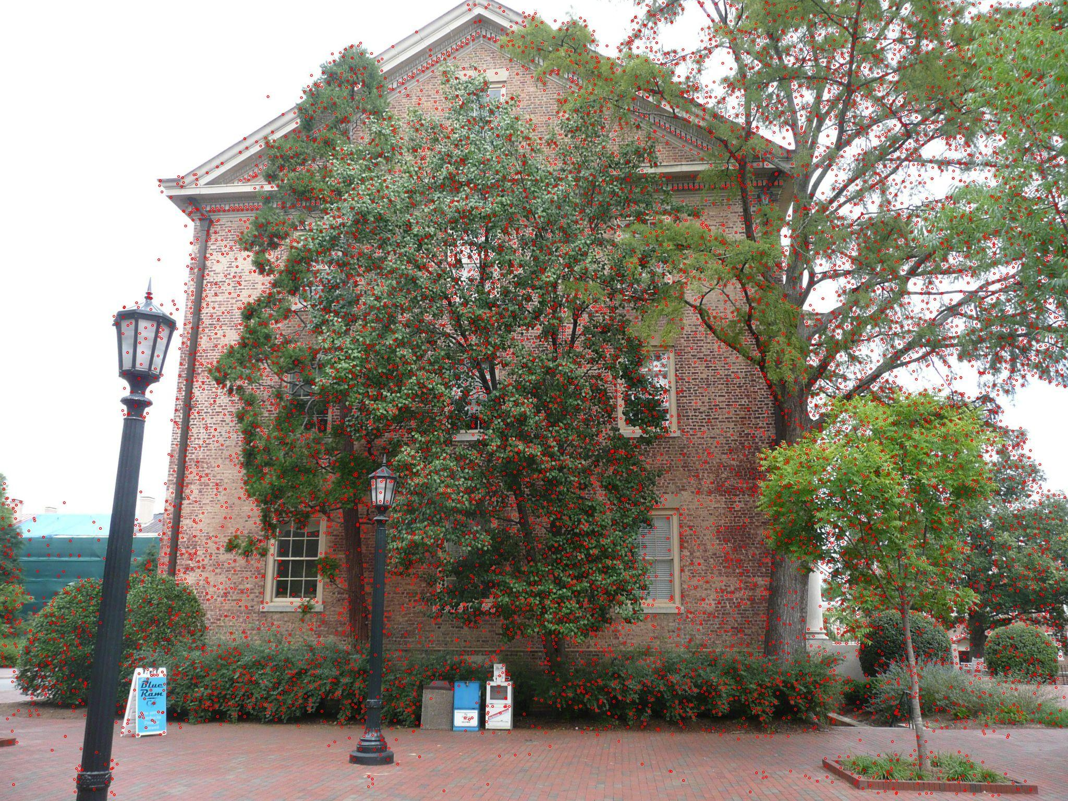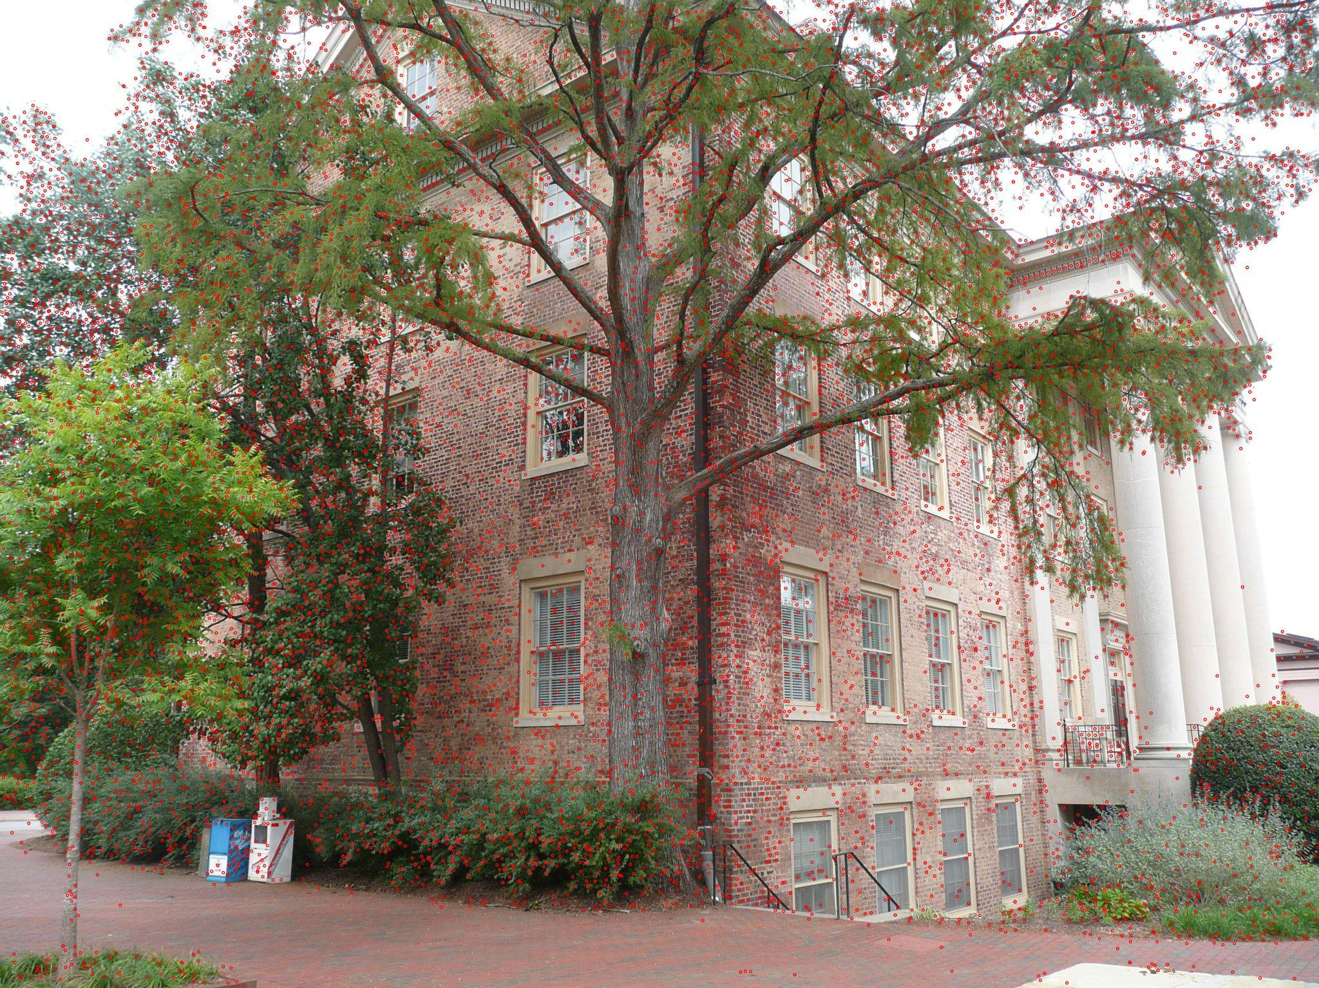

Overlap matches between img pairs 18-20 and 20-19:

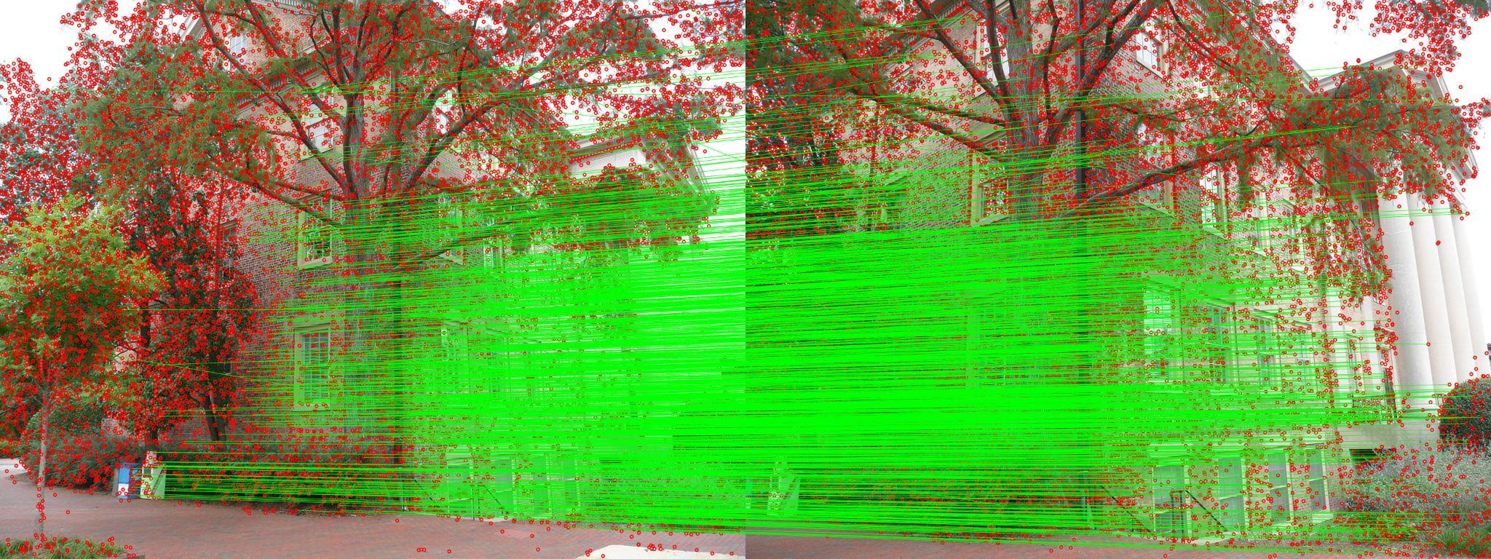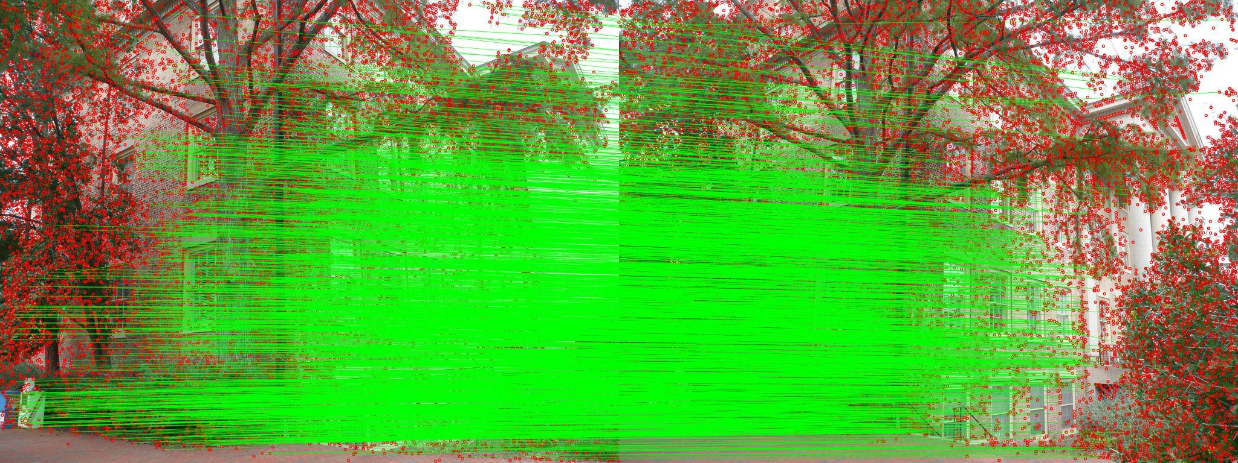

**Model stats table comparison:**

| **DATASET** | **Matching** | **Mean Reprojection Error** |
| --- | --- | --- |
| **10 Images** | Exhaustive | 0.56326 |
| **10 Images** | Sequential | 0.56012 |
| **20 Images** | Exhaustive | 0.571815 |
| **20 Images** | Sequential | 0.572863 |

**OBSERVATIONS:**

Datasets with **10 vs 20 images**:

In comparison to the 10-image datasets, the 20-image datasets yielded over twice as many points and observations.

The 20-image datasets had somewhat larger mean reprojection errors, which may have been caused by their greater complexity and propensity for error accumulation.

**Sequential vs exhaustive** matching:

Extensive matching yielded somewhat more points and observations for both datasets than sequential matching.

The mean reprojection errors in the 10-image dataset were slightly reduced by sequential matching, whereas the errors in the 20-image dataset were slightly increased.

In conclusion:

* The 10-image dataset with sequential matching yielded the lowest mean reprojection error (0.56012 pixels), according to the results, indicating that it may offer the best accurate reconstruction given its complexity.
* Nevertheless, at the expense of a marginally larger reprojection error, the 20-image dataset with exhaustive matching offered the most thorough reconstruction with the greatest number of points and observations.
* In a smaller scenario, the 10-image sequential matching would be better for maximum accuracy.
* The 20-image exhaustive matching would be a superior option for more thorough coverage and detail, particularly in larger or more complicated scenes, because the gain in reconstruction detail is far more than the increase in reprojection error.

1. **Gaussian Splatting**